**1 Cor 14:40 amp**

But all things must be done appropriately and in an orderly manner.

# WELCOME MESSAGE

We are filled with the utmost joy to welcome you to the team. This is your service in the local assembly. We find our work and duties fulfilling as we stay relevant in the kingdom. (Complete)

# WHO WE ARE?

Media has become an effective tool particularly in this generation for the promotion of the gospel. The uniqueness and reach of the internet today make it possible for the gospel to be spread across the globe in a short time. Utilization of media has therefore become imperative for many assemblies and the church worldwide to make impact through the internet and technology. The significance of Media in the church cannot be overemphasized as information through video, pictures and graphics have an important part of human living all over the world. Social media has become a fundamental platform for connections and basic interactions. The Church through its media must therefore take advantage of this to promote the gospel. As such our team has a mandate to assist in fulfilling the mission, vision and purpose of our commission. Should the M V P be stated?

Ultimately, a blissful experience in fellowship in every service must be prioritized. The gathering of the saints is a time of intimate fellowship with Jesus as our focus. Through the various ministrations, members are blessed and partake of the sweet fellowship. As a team, we seek to enhance, and broadcast this experience to people present in the auditorium and beyond. Our desired goal is to create the best worship atmosphere to the glory of the Father while being guided by the interests of our beloved man of God. Our dealings and duties must add to the fellowship and not distract or shift focus, from live sound production to announcements.

# CORE BELIEFS

**A Willing heart**

A heart ready for the Father’s pleasure is an essential element in service. You must be ready in your heart to go all out for the task given to you - Col 3:23 Eph 6:6-7

# Skill

Yes, service in the media Info & Tech is about a willing heart, however technical skill is essential. Team members in every service unit are required to grow in knowledge and in skill. Ensure to be better with time and innovative. Ex 30

# Diligence

**Love**

As a believer, one sign of your maturity is your ability to walk in love. We have received and are partakers of His Love, as such that love must be demonstrated through us. It is encouraged for all team members to walk in love towards each other in all things - Col 3:14 Roms 5:

# Service units available

Audio production - Live sound, Sermon editing, Podcast.

Camera operations - Photography, Videography.

Information team – Database management, Announcements, Communiques,

Social media Management

Creative Team

Live Stream Operation.

Lighting

Projection

Graphics Design

# SERVICES

WEEKLY:

Rhema (Sunday), Epoikodomeo (Wednesday), Hour of intimacy (Friday).

All service units needed for each service must be adequately prepared for the service. Service units are required to be present on Saturday for rehearsals and a check of setup for service the next day. i.e., for those scheduled to serve at the particular service. - Projection of lyrics, live and audio sound.

If you are scheduled to serve at a service, you are required to be present on Saturday (3-5pm) and early on Sunday (an hour before the start of service).

Programs/Conferences - Planning of such events will be communicated.

# ROTATION

Team members in various service units will join a rotation list.

# ABSENCES

All team members are required to be present at every service/program/conference. Continual absence without an excuse duty or a justifiable cause will lead to suspension.

In the case of not being able to make it for rehearsals, do well to communicate in ample time with the director or Unit lead. This will most likely result to a change in schedule for the said person to serve on a different service day. Rehearsals are essential to the effectiveness of the department.

# DRESS

By the nature of our work, our outfits are to be as easy going as possible. We do not seek to draw attention to what we wear in style or in colour.

All team members are expected to follow dress codes judiciously and be decent. Failure to adhere to this will lead to suspension.

# Training

General briefing and training are done for all new members by the director. All new members are required to go through a training process which includes in person meetings, rehearsals, on duty observation, and shadow responsibilities for at least three (3) weeks.

Periodic training sessions will be organized for various units. It is expected of all team members to fully participate with all seriousness.

# Requirements

1. Servant attitude - 1 Peter 5:1-6, Ephesians 6:6-7
2. Punctuality
3. Flexibility

**Identity and Guide**

The **brand identity** is the visible and tangible elements created to represent the commission’s image, that identify and distinguish the brand of the commission. It establishes a connection with the people and is what makes the commission recognizable to them.

**Logo:** A logo is the symbol or design used to identify the commission.

The TTOC logo consists of gold, black for a white or lighter background and gold and white for a black or darker background. It is a friendly logo, but it has a personal bubble, so always give it plenty of breathing room. If you look below, you’ll see the minimum logo-cushioning requirements and permitted permutations. The logo and wordmark should appear together whenever possible.

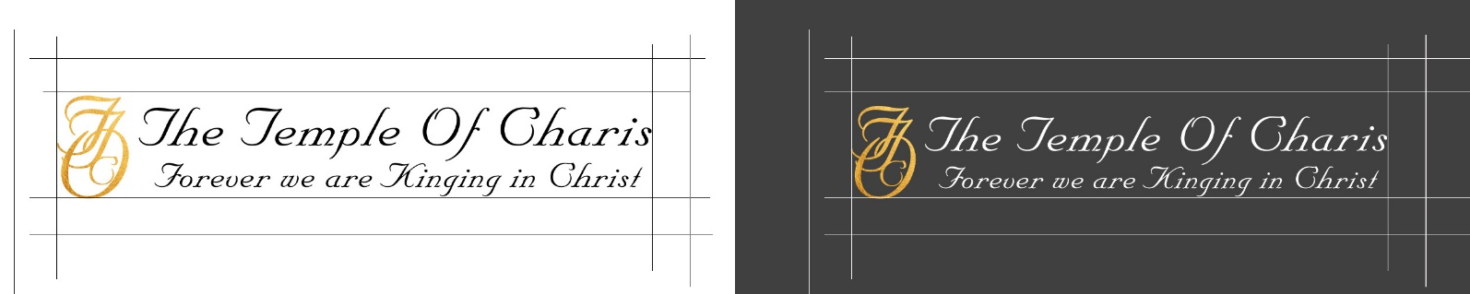

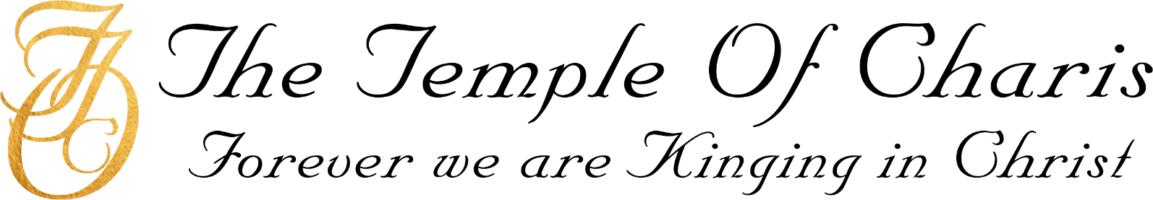



**Logo Don’ts**

1. Don’t place the logo on a background that doesn’t provide sufficient contrast.
2. Don’t distort the logo by smashing it, scrunching it, or scaling it disproportionately.
3. Don’t adjust the colors.
4. Don’t drop the logo mark and use the wordmark alone.
5. Don’t add unnecessary style such as textures.
6. Don’t change the alignment (vertical or horizontal) of the logo and word mark.

**Colours:** The TTOC brand has three primary (as in “main,” “dominant,” or “leading”) colors, chosen for aesthetic and accessibility purposes. They’re navy blue (#0000) , white (#0000) and black (#0000). Make sure to artfully and appropriately employ our primary color shades to suit your application.

White Space

Plentiful white space allows the colors to breathe and be happy. Embrace it. Use it. Love it.

Secondary Colors

The secondary colors are for supplementary use—outlines, buttons, divisions, illustrations, color accents. The little things.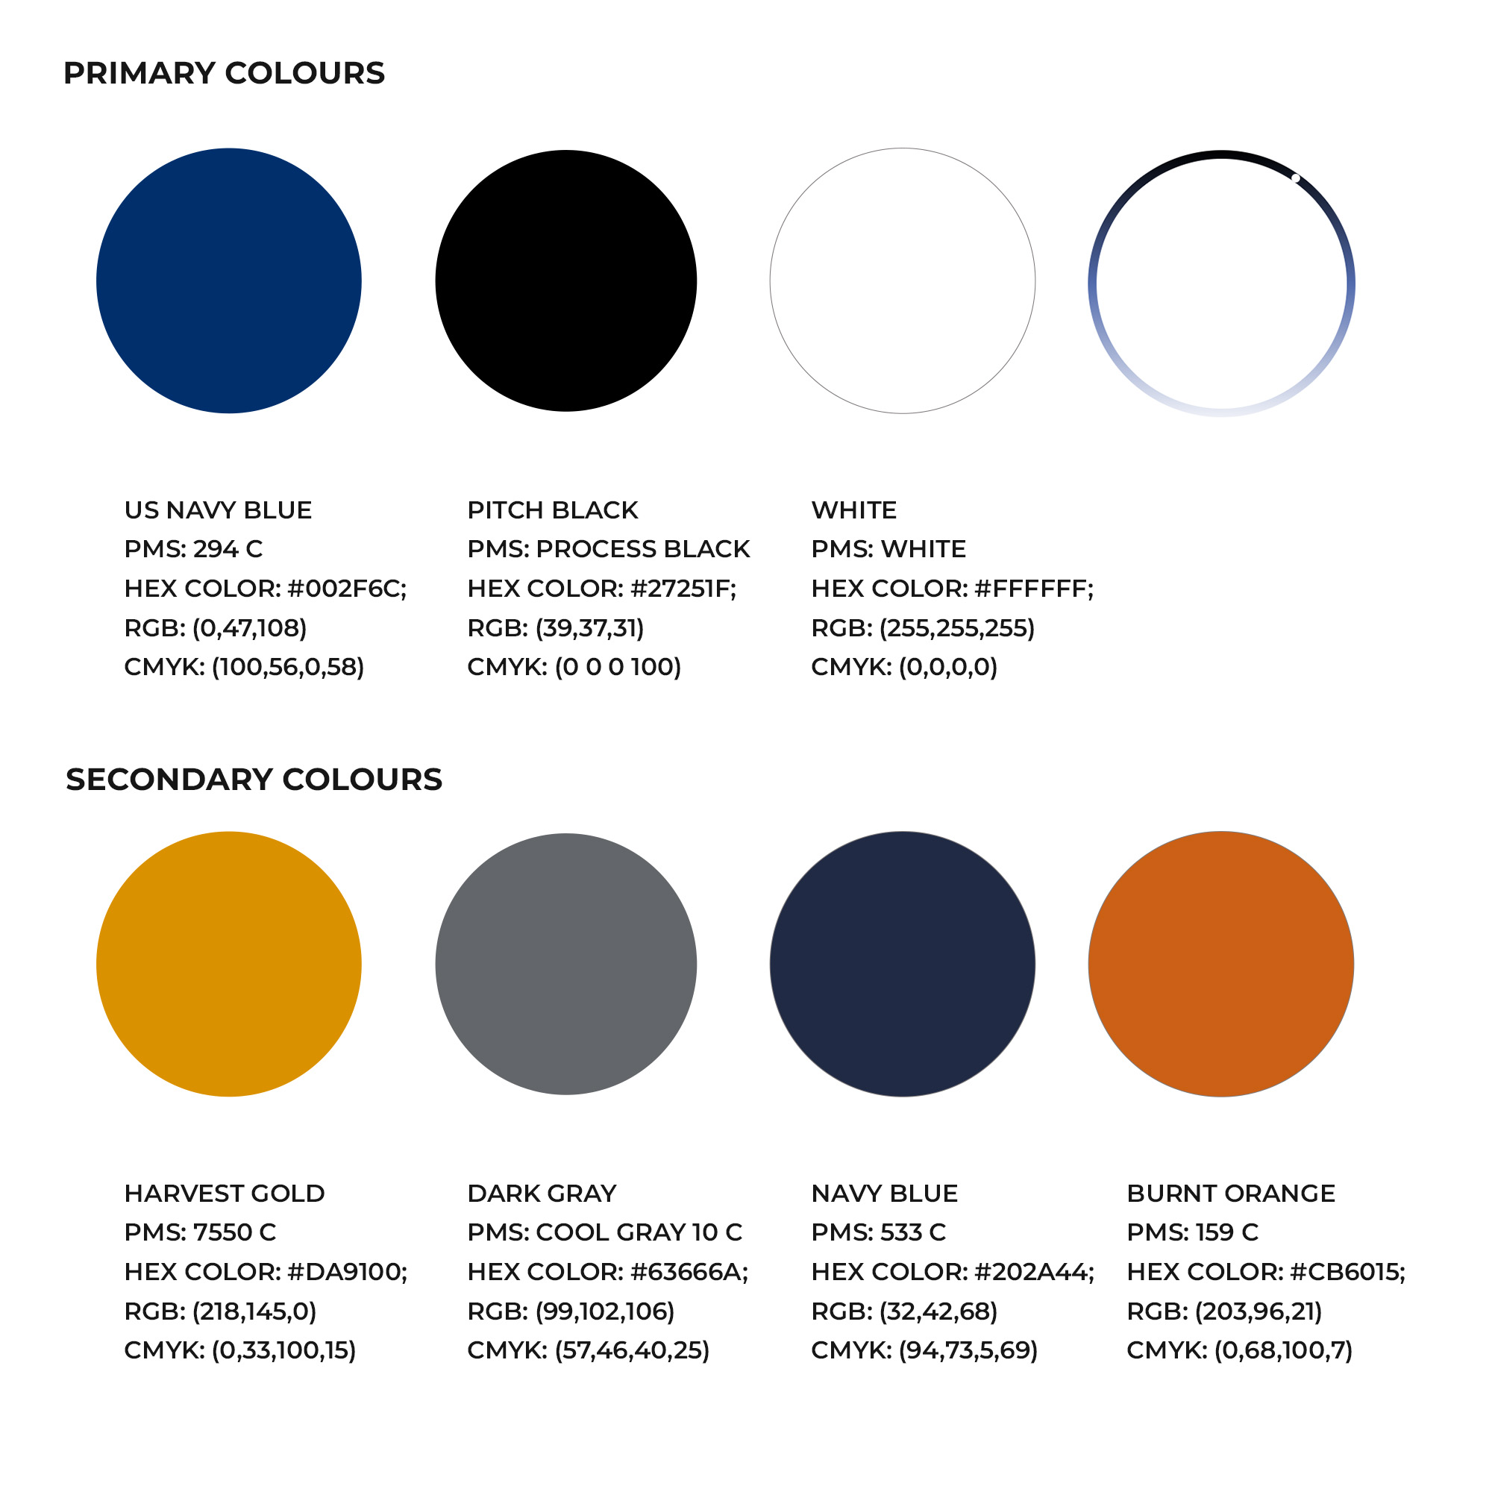

**Graphics Weekly Services:**

Programs/conferences

Typeface: Names Size Alignment

Margin values

*Line and height